Prithvi Dhirwani
D15C 25
MLDL
Practical 3
Application of Decision Tree and Random Forest for Classification Tasks

1. Dataset Source
The dataset used for this experiment is the Heart Disease Dataset, which is a real-world medical dataset commonly used for classification problems.
Dataset Source (Kaggle Mirror):
https://www.kaggle.com/datasets/johnsmith88/heart-disease-dataset

2. Dataset Overview
The Heart Disease dataset includes clinical details of patients and is used to determine whether an individual has heart disease.
Dataset Characteristics
- Approximate Records: 303 patient entries
- Data Type: Structured dataset (combination of numerical and categorical variables)
- Task Type: Binary classification
Key Features
Feature | Explanation
age | Patient’s age
sex | Gender (1 = Male, 0 = Female)
cp | Type of chest pain
trestbps | Resting blood pressure
chol | Cholesterol level in blood
fbs | Fasting blood sugar level
thalach | Maximum heart rate achieved
exang | Exercise-induced angina
Target Variable
- target
  - 1 → Presence of heart disease
  - 0 → Absence of heart disease

3. Mathematical Representation of the Models
Decision Tree Classifier
A Decision Tree classifier determines the output class by creating a series of decision rules based on feature values. At every node, the algorithm selects the optimal split using metrics such as Gini Index or Entropy.
Gini Index Formula:
Gini = 1 − Σ pᵢ²
Where:
- pᵢ represents the probability of class i
The dataset is recursively partitioned into smaller subsets until a stopping criterion (such as maximum depth or minimum samples) is reached.

Random Forest Classifier
Random Forest is an ensemble technique that builds multiple decision trees using random subsets of the data and features. The final classification result is determined by majority voting across all trees.
Final Prediction = Majority vote of individual trees
Advantages:
- Minimizes overfitting
- Enhances predictive accuracy
- Performs effectively with high-dimensional data

4. Limitations of the Algorithms
Decision Tree Limitations
- Can easily overfit the training data
- Sensitive to noise and slight variations in the dataset
- May grow too complex, reducing interpretability
Random Forest Limitations
- Requires higher computational resources
- Less transparent compared to a single decision tree
- Training time increases with very large datasets

5. Methodology / Procedure
Implementation Steps
- Obtained dataset from UCI/Kaggle
- Loaded dataset using Pandas
- Selected relevant features and defined the target variable
- Split data into 80% training and 20% testing sets
- Trained a Decision Tree classifier
- Trained a Random Forest classifier
- Evaluated performance using accuracy and confusion matrix
- Visualized the decision tree and feature importance
Workflow Summary
Dataset → Preprocessing → Train-Test Split
→ Model Training → Prediction
→ Evaluation → Visualization

6. Performance Evaluation
The models were assessed using the following metrics:
- Accuracy Score
- Confusion Matrix
- Classification Report (Precision, Recall, F1-score)
Key Findings
- The Decision Tree provides solid accuracy but has a tendency to overfit.
- Random Forest achieves better accuracy due to ensemble averaging.
- Random Forest reduces model variance and enhances generalization capability.
Overall, Random Forest performs more consistently and delivers improved predictive accuracy compared to a single Decision Tree.

7. Hyperparameter Optimization
Decision Tree Parameters
- max_depth: Controls maximum depth of the tree
- min_samples_split: Minimum samples required to create a split
Random Forest Parameters
- n_estimators: Number of decision trees in the forest
- max_depth: Maximum depth of each tree
- max_features: Number of features considered for splitting
Effect of Tuning
- Increasing tree depth may boost training accuracy but risks overfitting.
- Increasing the number of trees in Random Forest generally enhances performance.
- Proper parameter tuning improves model generalization on unseen data.

Code:
import pandas as pd
import matplotlib.pyplot as plt

from sklearn.model_selection import train_test_split
from sklearn.tree import DecisionTreeClassifier, plot_tree
from sklearn.ensemble import RandomForestClassifier
from sklearn.metrics import accuracy_score, confusion_matrix, classification_report

# ===============================
# LOAD DATASET
# ===============================
df = pd.read_csv(
r"C:\Users\vrkha\Desktop\MLDL\heart.csv"
)

print(df.head())
print(df.shape)

# ===============================
# FEATURES & TARGET
# ===============================
X = df.drop('target', axis=1)
y = df['target']

# ===============================
# TRAIN-TEST SPLIT
# ===============================
X_train, X_test, y_train, y_test = train_test_split(
X, y, test_size=0.2, random_state=42
)

# ===============================
# DECISION TREE CLASSIFIER
# ===============================
dt = DecisionTreeClassifier(random_state=42)
dt.fit(X_train, y_train)

y_pred_dt = dt.predict(X_test)

print("\n--- Decision Tree Classifier ---")
print("Accuracy:", accuracy_score(y_test, y_pred_dt))
print("Confusion Matrix:\n", confusion_matrix(y_test, y_pred_dt))
print("Classification Report:\n", classification_report(y_test, y_pred_dt))

# ===============================
# DECISION TREE VISUALIZATION
# ===============================
plt.figure(figsize=(12,6))
plot_tree(dt, feature_names=X.columns, class_names=["No Disease", "Disease"], filled=True)
plt.title("Decision Tree Visualization")
plt.show()

# ===============================
# RANDOM FOREST CLASSIFIER
# ===============================
rf = RandomForestClassifier(
n_estimators=100,
random_state=42
)

rf.fit(X_train, y_train)
y_pred_rf = rf.predict(X_test)

print("\n--- Random Forest Classifier ---")
print("Accuracy:", accuracy_score(y_test, y_pred_rf))
print("Confusion Matrix:\n", confusion_matrix(y_test, y_pred_rf))
print("Classification Report:\n", classification_report(y_test, y_pred_rf))

# ===============================
# FEATURE IMPORTANCE (RANDOM FOREST)
# ===============================
importances = rf.feature_importances_

plt.barh(X.columns, importances)
plt.xlabel("Feature Importance")
plt.title("Random Forest Feature Importance")
plt.show()

OUTPUT:
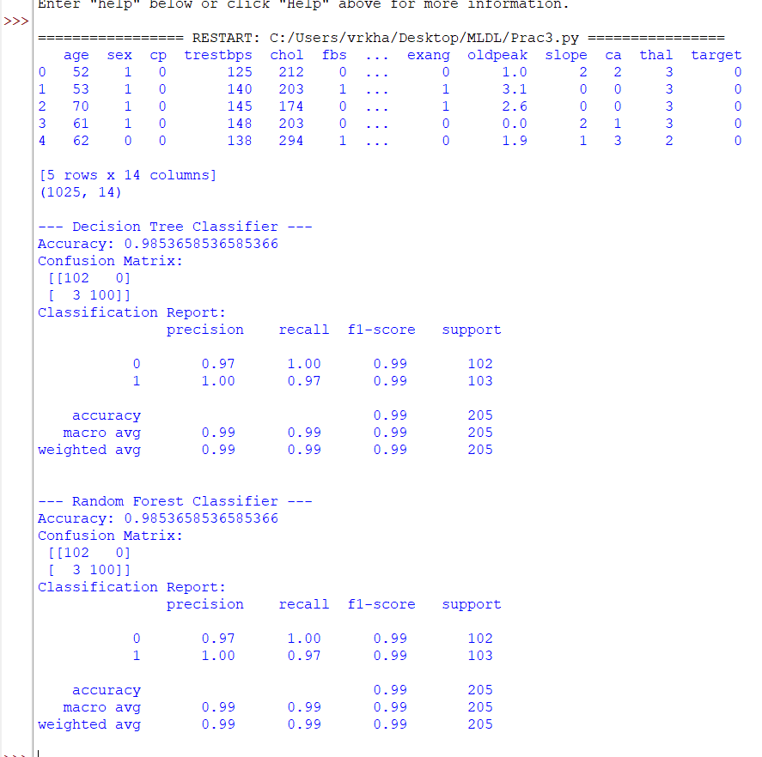

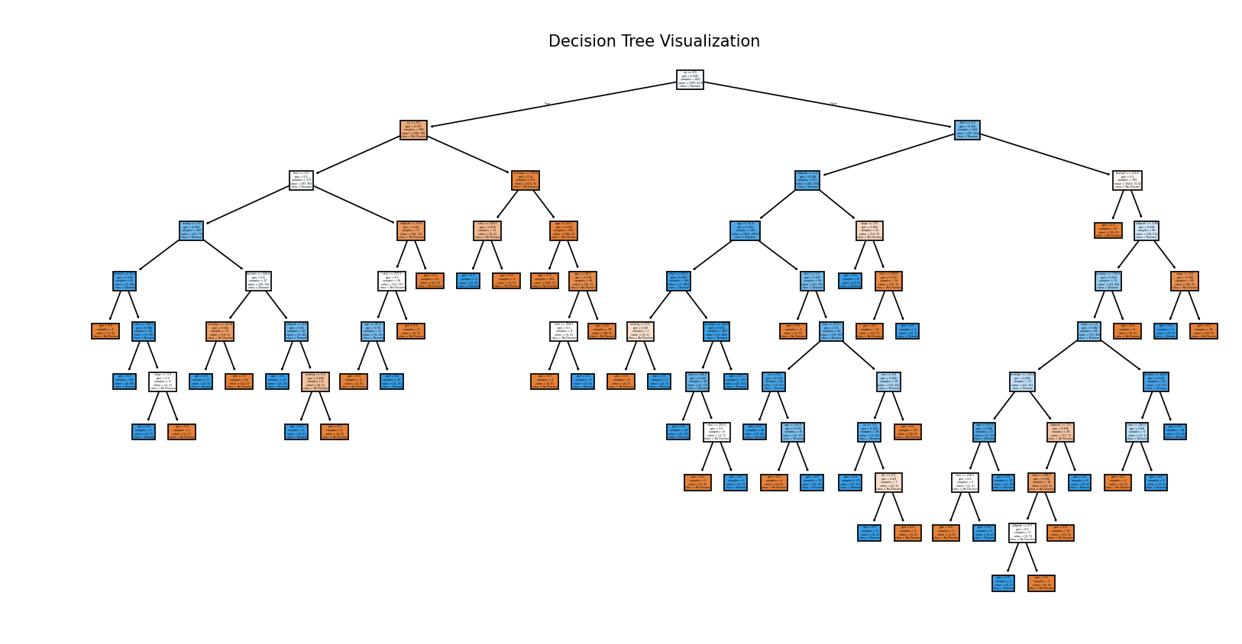
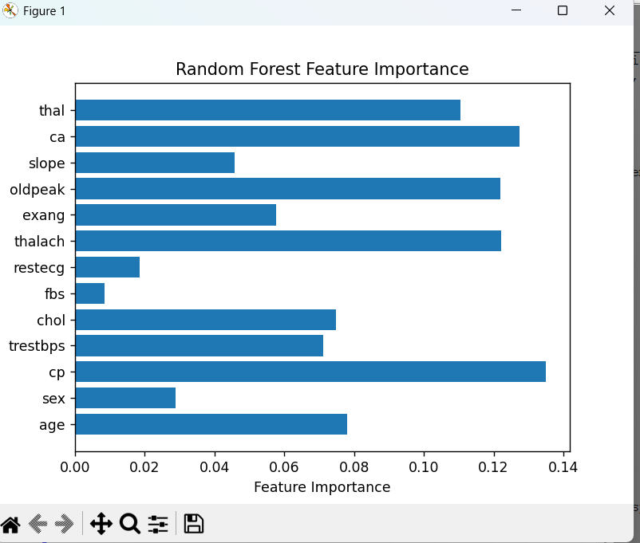
Conclusion
This experiment effectively illustrates the use of Decision Tree and Random Forest algorithms in solving a real-world classification problem. The Random Forest model achieves better performance compared to the Decision Tree because of its ensemble approach, which reduces overfitting and improves stability. As a result, Random Forest proves to be a more reliable choice for medical diagnosis prediction tasks.

